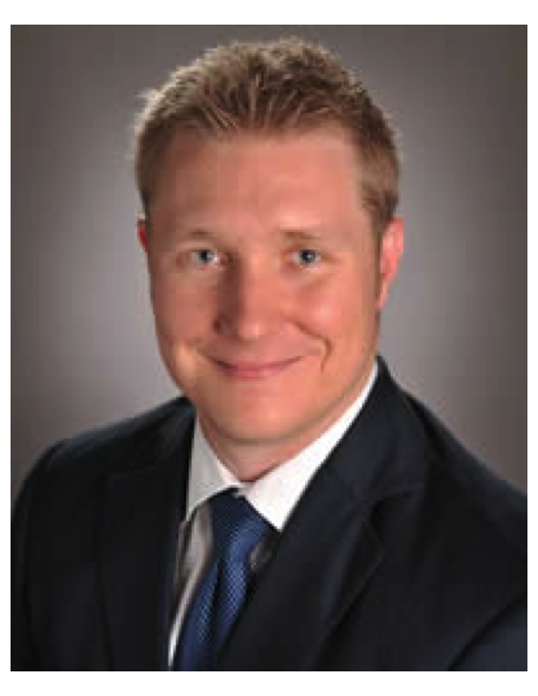
John McDonough, Founder and Principal

John McDonough is the President and CEO of Houston-based Studemont Group of companies. Studemont Group LP, Studemont Group College Funding Solutions, LLC, Studemont Group Advisory. John is the Houston Managing Director for Cool Springs Financial, LLC (www.coolspringsfinancial.com) and co-founder of Evolution Selling Inc. (www.collegefundingevolution.com) an advisor “think tank” and business-training firm. John is also creator of the Future Creation Process™ and Without Doubt™ series and former host of the Money Myth Busters Radio Show on 100.7 FM. He has served clients financial needs since 2001 and trained advisors since 2004.

Studemont Group is a full-service firm catering to the wealth management, college prep and financing, and retirement planning needs of pre-retired and retired clients. It is the goal of the firm to help clients address their financial doubts and plan to secure a stable financial future.

In his practice, McDonough helps clients overcome their concerns about stock market volatility, rising taxes, saving enough to last the duration of their retirement and more. He created the Future Creation Process™, Money Without Doubt™ and Retirement Without Doubt™ personal finance systems, designed to help address financial concerns and create a workable plan to eliminate doubts and increase confidence in money and retirement. He authored his first book entitled How to Give Your Child a 4-Year Education Without Going Broke. He is currently authoring his second book Money Without Doubt™.

In addition, McDonough has also worked to educate Houston area residents through his former radio show Money Myth Busters on 100.7 FM KKHT. Through the weekly broadcast, McDonough strived to “bust” conventional wisdom of financial myths and answer listeners’ questions. Some of his show topics included: why the “Buy and Hold” investment strategy is a thing of the past; complacency and your money; myths associated with financial products; how not to be a slave to the lender; insider trading in congress, and more.

McDonough’s credentials include being an Investment Advisor Representative of 212 Advisory Group, LLC d/b/a/ Studemont Group Advisory. He is also life and health insurance licensed in Texas. He has furthered his education by taking finance courses at both the Wharton School of Business and Rice University, where he has completed the necessary coursework for the well-respected CERTIFIED FINANCIAL PLANNER™ designation. McDonough graduated with a Bachelor of Science in Business Administration with an emphasis in marketing from the University of North Carolina in Charlotte. He was also twice honored as the Manager of the Year with his previous firm.

In addition to his commitment to continuing education, McDonough also belongs to several financial membership groups including Society of Financial Service Professionals (FSP), and the National Association of Insurance and Financial Advisors (NAIFA), and New First Financial Resources, LLC (FFR) (where he currently serves as a board member), all esteemed organizations with the goal of education members in the latest financial practices and upholding the highest industry standards. McDonough has demonstrated an excellence in his field through his continued invitations to the Million Dollar Round Table – Top of the Table as well as the Forum 400, both exclusive organizations honoring financial professionals who have reached commendable professional benchmarks.

McDonough’s commitment to business ethics is reaffirmed through his membership to the National Ethics Association (NEA), an organization dedicated to acknowledging financial professionals who uphold the highest ethical standards in their practice and who have passed its extensive background check process for criminal, civil and business violations, as well as provide proof of professional licensing that authorize him to offer financial services. Studemont Group is also a member of the Houston Better Business Bureau.

McDonough is a former semi-professional soccer player and a three-time participant in the BP MS 150 Houston to Austin bike tour benefiting the National Multiple Sclerosis Society. He is also involved in the Prince of Peace Catholic Church as well as the Northwest Bible Church.

McDonough married his high school sweetheart, Edna, in 2004. Together they have two daughters and reside in Spring, TX.

Keith Beggs, Education Consultant
Keith Beggs is a vital member of The Studemont Group and has helped grow and expand the company’s already thriving business. With over 10 years’ experience in the business he has developed a passion for helping families achieve their financial and retirement goals. He received his Bachelor of Business Administration from Sam Houston State University in 2004, where his focus was in marketing. In addition, Keith holds both his Series 65 and insurance licenses. Keith is married to his beautiful wife of 3 years, Kristina Beggs. They are members of Houston’s First Baptist Church and are actively involved in their Sunday school. Keith is an avid golfer, boater, enjoys serving the widows of his church and traveling with his wife.

